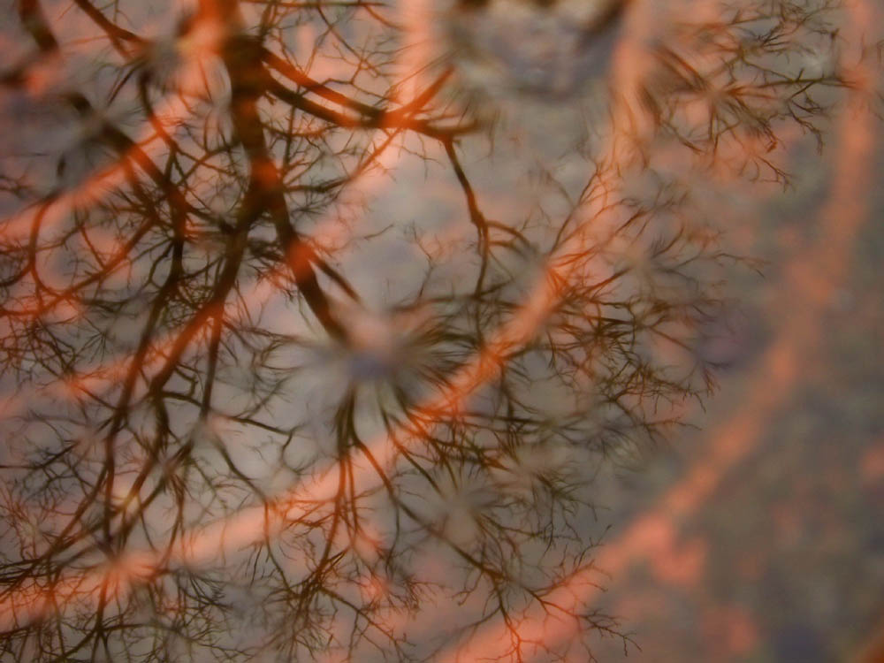

Where Do Ideas Come From?

It has been said that one of the best ways to guarantee a steady stream of new ideas is to put people together who share different knowledge and perspectives on life. The different viewpoints offered by such a group offer a variety of levels of insight and ways into understanding, and the result is one where the generation of ideas flow easily and quickly.
This was certainly the case with Creative Partnerships London North’s first project, Where Do Ideas Come From? For this, each school was requested to provide a group of around ten participants, made up from a range of people from across the school community, including a member of the senior management team, a few students of different ages, a selection of teachers from across the curriculum, a teaching assistant, and a parent governor, parent or community member. The group were then paired with a musician and a photographer to work together on an audiovisual project exploring sense of place.
As projects go, Where Do Ideas Come From? was quite a short project. After a preliminary visit from the artists to check fine detail with each school’s creative partnership coordinator, the project then began with the participants working with the artists over three separate days. On the first day the task was explained. Each participant was given a digital camera and asked to take photographs of their surroundings. A location was chosen, for example the playground or, in one case the local allotments, and the group were let loose to photograph anything that grabbed their attention. Next was viewing of the photos: the pictures were projected and commented on with the result that the participants became not only more aware of what makes a good photo but also learnt about the thinking and values of each member of the group as each spoke about why they had taken such and such a shot. On the second day the participants were once again given the cameras and more photos were taken. Once again they were viewed but this time they were asked to choose their ten favourite photographs (one for each photographer). Not an easy task as by now the photographs would number more than a thousand; however, with ruthless editing, a top ten was established. The third day concentrated on the creation of a musical soundtrack for the chosen photographs. As each photograph was projected, the group experimented with how each picture could be interpreted through sound using the school’s musical instruments. Gradually a composition emerged which was performed to the changing photos and this was recorded for later viewing and listening.
Of course, the project was about more than simply the creation of an audiovisual presentation. The participating groups became a metaphor not only for the whole school working together on a shared understanding of purpose, but on that whole school working in partnership with outside creative practitioners. Likewise, the project’s theme of sense of place also embraced the possibility of considering where the artists and school were at in terms of their values and relation to creative learning. The artists too benefited from working in collaboration with another artist of a different discipline and could be seen to be learning from each other’s working methods. This mutual learning in turn was a good signal for the rest of the group.
As staff and pupils discussed their ideas and collaborated, conventional hierarchal roles were reinterpreted. It was evident that the students (no matter how young) thought seriously about the project and in similar ways to the grown-ups; they were able to offer interesting ideas, and also took some of the best photographs. In like manner, the adults were seen as fun loving individuals who also shared many of the same anticipations as the younger people. The environment was also conducive to the artists learning from each other as well as the other members of the group. In this way, as the sessions progressed a sense of community established and this in turn informed the work.
Unlike other working scenarios that can be so demanding in terms of time allocated, numbers participating and limited resources, Where Do Ideas Come From? was designed to relax the usual tension between process exploration and product. By using minimal instruction the participants were free to take responsibility for their work and embark together on a genuine journey of discovery. The project then was very much concerned with maintaining a special focus on process and specifically how everyone in the group (and by extension therefore the wider school community) could relate to the process of creativity.
An important part of this process was ensuring that there was enough time built into the project to discuss its many surprise outcomes. This opportunity to reflect and discuss was enlightening for staff, students and artists alike and was also helped by one of the project’s more novel aspects - on each of the three days caterers were brought in to provide a special lunch for the group to share. This extra opportunity for exchange greatly assisted in the participants’ perception of themselves as a team on a shared mission.
After all the schools had participated in their three days, their audiovisual presentations were collated for everyone to see and were presented at an event to which all the groups were invited. Many of the groups were also inspired to show their work at various presentations at their schools: one school made greetings cards from the photos to raise school funds, another created an art installation for one of their parents evenings, at least one school invested in their own digital cameras, and at another the parents who took part continue to be involved in the school’s Creative Partnerships projects. The artists also gained from the project. By being able to reflect on the process and discuss their findings with each group they were able to refine their work not only in terms of their education work but also in their own practice.

